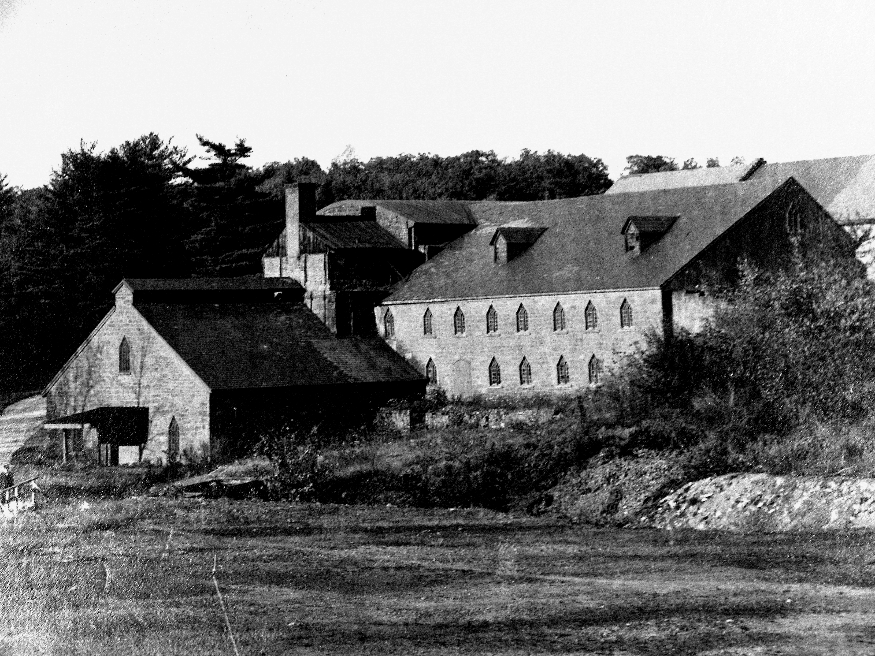
Cornwall Archival Survey Project
Contract Number SH06/07.1
Historical Society of Pennsylvania
Final Report of Work Performed
CHRISTOPHER R. DOUGHERTY
MAY 2009

I. Project Overview:
This report seeks to provide an overview of collections surveying activities conducted during the period of February 2008 to May 2009 at the Historical Society of Pennsylvania (HSP) relative to the Cornwall Iron Furnace in Lebanon County, Pennsylvania. This report is broken into two major sections. The first consists of individual overviews of collections surveyed while the second section attempts to connect specific collections at HSP to research questions articulated in the Cornwall Iron Furnace Interpretation Plan of 2006. Where possible, this summary will orient researchers to specific collections at HSP that may offer insight into questions outlined in the Interpretation Plan. Throughout the survey process, special attention has been paid to the primary and subthemes developed during the interpretive planning process as a way of expanding the narratives told about the Furnace and its workers. With very little correspondence and most of the primary sources consisting of statistical or tabular data found in inventories, daybooks, material log books, production books, and others, some effort has been made to aggregate this material to derive larger conclusions about the social lives of workers and the business characteristics of both the Cornwall Furnace and the Ore Banks Company. With regard to individual questions in the interpretive plan, where possible attempts will be made to address the relative strengths and weaknesses of collections at HSP versus those present at the Pennsylvania State Archives in Harrisburg.

II. Overviews of Collections Surveyed

The following collections were determined to possess information relevant to the Furnace and/or the Cornwall Ore Banks Company:

MG 1454—Series 6, Box 332: Judge John Cadwalader Papers
Born in Philadelphia in 1805 to General Thomas Cadwalader, John Cadwalader graduated from the University of Pennsylvania in 1821 and four years later entered the bar. In 1830 he became solicitor for the Second Bank of the United States and served as a militia commander during the Nativist riots of 1844. Cadwalader then served as a United States Representative from 1855-1857. A fierce antebellum Democrat, in 1858 he was appointed by close political ally James Buchanan as judge of the U.S. District Court for Eastern Pennsylvania. Later he served as Assistant Secretary of State in the Grant and Hayes Administrations. Cadwalader was widely regarded as one of the nineteenth century’s most acute legal minds. “He was,” wrote the New York Times in their 1879 obituary, “one of the most remarkable jurists this country ever produced.” Cadwalader distinguished himself in the so-called “Blackburne Cloth Cases” where he represented the United States government suing for a large quantity of undervalued cloth. Blessed with a capacious memory, Cadwalader was known to cite opinions down to their book and pages without hesitation and he developed competencies in business, maritime and commercial law.
For the purposes of this survey, Cadwalader’s correspondence relating to his defense of the Grubb mining claim was thoroughly assessed. The crux of the matter dealt with the disputed right of the heirs of Burd and Henry Bates Grubb, their agents and assigns, to extract ore from any of the three hills at Cornwall. Apparently, as early as 1842, Robert, Ann, Margaret, Isabella, Robert and William Coleman alleged that several agents of the Grubbs “trespassed and extracted...” iron ore in violation of an ownership agreement. Later the Colemans alleged that “John Snow, acting under the orders of Samuel Houck trespassed and extracted on the value of one thousand dollars worth of ore, the property of Ann, Margaret, Sarah, Isabella, Robert and William Coleman. At the root of the dissention was a legal disconnect between the division of the shares of the mine and the geographical disposition of these rights. Meaning, while all parties could agree to the 1825 96-share division scheme—with the four Coleman sons receiving 20/96 each and Edward B. and Clement B. Grubb retaining 16/96—how this division would be practically articulated had no legal precedent. In the absence of a workable resolution, litigation propagated wildly. While a survey had been executed following the first partition of the Grubb shares in 1787, Cadwalader was quick to understand that such property demarcations were moot considering the peculiarities of ore geology. Prior to the 1864 solution advanced by the Cornwall Iron Ore Company to divide total mine production proportionally, the new realities of mining geology temporarily rendered conventional legal precedents on property obsolete.
Cadwalader was part of the Grubb’s “dream team” of lawyers that included Lebanon and Lancaster county attorneys like Levi Kline as well as the up-and-coming Lancaster lawyer Thaddeus Stevens, later to become a radical Republican of considerable power in the Senate after the Civil War. In his description of the Philadelphians involved in the “battle of giants” Frederick K. Miller neglects to mention Cadwalader. Though it is unclear, presumably Cadwalader was in private practice, as he was between his service at the Second Bank of the United States and his Congressional stint. It is also plausible that he knew his client Edward B. Grubb, both socially and professionally, Grubb residing at 28 Walnut Street in Philadelphia during the 1840s. What role Cadwalader had in precipitating a resolution to the case is unclear as is his role in the coordinated legal defense. Though shrewd, his argumentation could not expedite a termination of the case until 1869.
The case, initiated in 1842 by the Colemans, centered upon their allegations that agents of the Grubbs had entered into their mine land and had “carried off” a substantial quantity of iron ore. Apparently, the case was unresolved by county courts and although the parties forged an agreement to equitably distribute the ore in 1848, this arrangement soon disintegrated. A review of the opinion rendered in 1854 and subsequent scholars’ interpretations reveals that while the case dealt superficially with trespassing, the root cause of the Colemans’ complaint was the growing cost of subsurface mining. Thus the division of the property in pursuance with the 1787 agreement posed several problems when the mine owners confronted the peculiarities of the site’s geology and the economics of capital-intensive underground mining. As the presiding Judge P.J. Pearson of the Pennsylvania Supreme Court argued in his 1859 opinion, any valuation of the damages due to the family had to incorporate an estimation of, “the value of the ore from 1848 to 1853, as between the Messrs. Colemans and Grubbs; the difference in the relative quality and value of the ore mined, sold and used by Messrs. R. W. and W. Coleman, and George D. and R. Coleman, from the 1st of April 1853 to the 1st of January 1859, and the difference in the expense of mining between the same periods.”
Though it is altogether unclear what role John Cadwalader had in actually composing the argumentation for the Grubbs’ defense, it is clear that Cadwalader wanted to exploit a “supplemental memorandum” designed to clarify the original relationship defined in the 1787 agreement. Cadwalader, it appears, wanted to base his defense on the lateral arrangement of ore veins seemingly across property boundaries. Further he wanted to advance the claim that rights to the ore were preeminent to rights for land. Integral to this claim was his invocation of the section of the “supplemental memorandum” that gave the Grubb heirs “full liberty and privilege of ingress, egress, and regress to and from the said mine hills…and power to dig and sink shafts drive drifts and carry away any ore that may be found to extend beyond the limits of the said surveys.” Cadwalader, whose knowledge of maritime, bankruptcy, and commercial knowledge was unexcelled, wrote in a draft of a motion that “The limits of the veins in their extensions of ore beyond the Hill has not been ascertained: but a legal implication arises from the final agreement or memorandum apprehended to the articles of 31 May 1787 mentioned below that they may extend as far as the Iron Works of Cornwall Furnace and the water which furnishes their motive power and into the plantation allotted with the site of the Furnace in pursuance of those articles.” Additionally, Cadwalader also attempted to induce geologists Henry Darwin Rodgers of Boston and Richard C. Taylor of Pennsylvania to serve as expert witnesses for the case but was unsuccessful. It is debatable whether research into Cadwalader’s role in the Grubb defense will yield positive results, though the 1854 case and the 1869 appeal beg for more thorough investigation. For interpretive purposes, a discussion of this case can illuminate the idea of organically-developing concepts of property law in a mid-nineteenth century industrial context.

MG 1967A-B—Grubb Collection:

Upon assuming Cornwall Furnace after the death of their father in 1754, Curtis and Peter operated the furnace, forges and mine hills profitably for nearly a half-century, their business buoyed by war and the locational advantages of their site. While many Pennsylvania ironmaking operations benefited from close proximity to water power and timber, Cornwall held a distinctive advantage in its almost inexhaustible stores of iron ore and limestone. Cornwall’s output of 24 tons a week during the 1760s was sufficient to keep six neighborhood forges operational, suggesting a vigorous market for finished goods in both the rapidly urbanizing Pennsylvania southeast but also in the newly settled trans-Susquehanna hinterland. The Grubb Family Collection, then, is instrumental in broadening our knowledge of the operations of the furnace, organization of labor, and the relative social capital of the furnacemasters themselves. Of particular interest since Phase 1 of the survey is a more thorough investigation of racial slavery in the industrial sector in 18th century Lebanon County. New material gleaned from this Collection shows how legal instruments delimited slaves’ mobility while simultaneously enhancing slaves’ furnace-specific skills. Additionally, some documents within this collection also provide greater definition of the story of Robert Coleman’s acquisition of the furnace from the perspective of the relinquishing family.
Throughout the 1770s-80s, regular correspondence between Peter Grubb Jr. and a host of social and economic partners provides tremendous insight into how the Grubbs conducted daily business, were perceived by high and low Pennsylvanians, and operated within the business culture of the Province with its carefully defined codes of obligation, reciprocity, and gentlemanly rectitude. It appears that much of the overseeing of the Furnace during the 1770s-80s was delegated to a rough Welshman named Evan Evans who monitored laborers and ensured that the vital work of the colliers was executed to Peter Grubb’s exact specifications. Evans was, in the estimation of economic historian Kenneth Rassler and later Paul Paskoff, was one of the most important men at the Furnace. In the era before statistical control of inventory and product flows, Evans ensured that crucial raw materials were produced or acquired and inserted into the process at the correct juncture. Yet Evans was not a radical free agent. Letters show Evans deferring to the accumulated wisdom of Peter Grubb: “The bearer has set two pits,” Evans wrote Grubb in the 1780s, “and the leaves howl’d but you must be the best judge whether he shall go in and fire them as I don’t like to run the chance without your orders.” Evans also kept Grubb abreast of laziness, tardiness, and absenteeism among laborers. “Shroff left word with his wife last Sunday he was going to M. Hope and instead of going there or staying at his work here I found him in H. Mark’s harvest field, where I gave him and Marks both a sharp lecture….” Evans also served as Grubb’s eyes and ears in the markets, coffeehouses, and other spaces of economic interaction. He reported on the price of iron in Lancaster, whether buyers will give advances before casts, and bids for work on the furnace.
While business matters consumed Peter Grubb, it appears he was often in Lancaster where he appeared as one of the city’s more prominent and benevolent citizens. Peter Grubb was the recipient of several requests for money—some from apparent strangers; others like Elizabeth King were members of the Grubb’s extended family. King, a widow, reminds Grubb that she has “no way of getting a penny” and implores him to give her the proceeds of a horse that Grubb owed her. Among the upper reaches of the Provinces social strata, King’s reminder of “promises you made me of doing generous by me…and…the charge your uncle gave you on his deathbed,” would have demanded attention. With both the welfare of society’s weakest and economic institutions like credit rooted in the bedrock of word-as-bond, such letters indicate that Peter Grubb enjoyed full faith and credit for satisfying his legal and extralegal obligations.
Unfortunately, with the exception of Evans’ accounts of laborers, a 1787 indenture binding a slave to a furnace, and individual labor contracts, the Grubb correspondence is generally barren of source material relating to laborers’ social, economic, legal situations. Some of the labor contracts deal with workers at Mt. Hope, but it can be assumed that the instrument was similar at Cornwall. Workers like colliers were engaged in individual tasks such as the contract with Abraham Hair which demanded delivery of “Coals of five hundred Cords of wood more or less….” Hair’s contract also demanded high quality and date of delivery: the product was to be “good sufficient Coals without brand to be Delivered in the course of Next Summer.” Other contracts exist between the Grubbs and workers that specify work on the furnace stack. An indenture which bound a slave “Negro Bill” to a hammerman, John Hare, existed like a contract but with appreciable disadvantage toward the slave. While the 1787 indenture bound Hare to clothe, feed, and teach Bill the art of the hammerman, it also rendered the contract moot if Hare was to remove Bill from the forge site. As observed in Phase 1 of the survey and in sundry books at HSP, slaves though prevented from leaving the furnace ground, were paid and could purchase items at the company store.

Most of the post-Revolutionary War Grubb correspondence tells the story of a socially-connected Peter Grubb, Jr. attempting to direct the operations of the furnace despite the involvement of his brother Henry. As Frederick Miller indicated in his survey of the economic development of the county, the curious dual ownership arrangement led to a “complicated tangle” which later precipitated the Grubb v Coleman case. As early as 1785, Peter Grubb II has initiated discussions with his Lancaster lawyer, Jasper Yeates, as to the feasibility of selling off his share of the Cornwall property. Yeates was not confident: “Neither do we imagine we could forward any contract between you and your brother. He would be jealous of us and suspicious of every thing we could suggest or hint to you for your mutual benefit,” Yates wrote in 25 January 1785. By June of 1785, Yates had prevailed upon Henry and Peter to amicably divide the property in two separate legal actions in Lancaster and Dauphin Counties. By the Fall, an impetuous Robert Coleman—who purchased Peter’s share of the furnace and mines—is demanding that the Grubbs forfeit all possible information relating to the condition of the furnace. The information he required was not forthcoming. A frustrated Coleman writes to Grubb in an 25 October 1785 letter:
I otherwise expected to have your final answer respecting the forge before this time. If you think to carry on the forges on your own account you will find yourself much mistaken and will put me under the necessity of taking some disagreeable measures to prevent it as I am determined that no person shall reap a benefit from that Estate without my enjoying the share I am entitled to.

The debate is so rancorous that at one point in the winter of 1786 Peter Grubb jots a rare introspective and melancholic line: “My Head has been keen for business but now it’s a squash.” This is indicative that the sale process was not without its stress.

MG 212—Forges and Furnaces, Cornwall Iron Furnace:
The Cornwall Iron Furnace collection of MG 212 consists of 133 volumes detailing the input and output flows of products, raw materials, and consumables at the furnace from 1765-1884. Most, if not all of the volumes were donated to HSP by Margaret Coleman Freeman Buckingham, who also deeded the Cornwall property to the Commonwealth of Pennsylvania in 1932. Due to the tabular and statistical nature of the data reviewed, wherever possible efforts have been made to aggregate and analyze data over time. Much of the tabular data contained in the ledger books closely resembles price, wage, food and drink consumption, and productivity information contained in MG 182 at the Pennsylvania State Archives in Harrisburg. Close integration of material from both the State Archives and HSP can provide insight into wages, prices, productivity, leisure patterns, ethnic composition of workforce, and general quality of life throughout the end of the eighteenth century and throughout the nineteenth. A close analysis of these material and commodity flows can yield insights into the relationship of wages to expenditures and can assist researchers a better definition of real incomes at the furnace during the early part of the nineteenth century. Additionally, determining whether price and wage fluctuations were similar to those changes in agricultural sectors or were altogether more severe may affect how scholars interpret Cornwall workers’ adoption of an “industrial” consciousness. Invariably this question is linked to one of the greatest questions framing the discussion of early industrialization: whether standards of living improved during this period when some segments of life at Cornwall were assuming a typically industrial character. This analytical mode has been used to determine sectoral relationships between the iron ore company and its industrial consumers. For scholars wishing to determine social conditions during the ore mine’s period of regional and international prominence, roughly 1865-1972, collections are not as fruitful as those found at the State Archives.

Secondary Sources, Minutes of the Cornwall Ore Bank Company, and other non-manuscript Collections at HSP:
Some non-manuscript collections provide much needed context necessary for understanding the growth and evolution of the Cornwall Furnace and the Ore Banks Company. Frederick K. Miller’s excellent three volume The Rise of an Iron Community: An Economic History of Lebanon County, PA 1740-1865 is excellent in its treatment of worker wages versus prices. With its close attention to wage and price fluctuations over time, pay scales for job classifications, and general furnace productivity throughout the eighteenth and nineteenth centuries, Miller’s text and bibliography is a good roadmap to both collections at HSP and at the State Archives. To be sure, while sources have dictated that Miller’s analysis is heavy on the economic analysis, he is also attuned to the way the Coleman family’s social capital influenced the larger economic realities of Lebanon County. “The Colemans, he alleges, “had ample financial resources to erect furnaces and keep them up-todate, resources which no other family had.” For a quick chronology of the evolving ownership arrangements at the furnace, researchers would profit from Dan Graham’s short sketch appearing in the finding aide for Iron and Furnace Books at the Historical Society of Pennsylvania, 1727-1921, a guide to MG 212.
Jack Bitner’s Mt. Gretna: A Coleman Legacy enjoys the honor of being at the same time one of the most elaborate and most questionable treatments of the Coleman clan, their cultural import, and their philanthropic and economic legacies. Lacking a full-length overview of the Colemans’, we are left to ponder the veracity of some of Bitner’s more perplexing assertions. While Bitner’s approach to Robert Coleman’s founding of the firm, a more analytical take on Coleman’s success within the late-18th century business and credit world of debilitating personal exposure can be found in Frederic Shriver Klein’s “Robert Coleman: Millionaire Ironmaster.” But while Bitner is content to blame the ironmaster William Stiegel’s “personal excesses” and Klein suggests the practical wisdom of intermarriage, neither synthesizes the other’s conclusion and claims that familiar intermarriage in an 18th century business context may have protected private citizens from personal exposure.
Perhaps more perplexing is Bitner’s assessment of young Robert Habersham Coleman as an overcivilized, academically-mediocre, social dilettante whose insensitivity toward money predisposed him to the aggressive business strategies of the iron company’s chief counsel, Artemis Wilhelm. Bitner believes Coleman was captivated by Wilhelm’s plan to “spend and reinvest all income” and allow just the scant principal for emergencies. It is altogether unclear whether R.H. Coleman adopted this approach—if anything the construction of two anthracite furnaces in the late 1870s may have been slightly retrograde considering technologists like John Fritz were installing Bessemer converters in places like Bethlehem as early as 1864. That Coleman was temperamentally adverse to conservatism in business may be borne out in the records of his railroad speculation in Florida during the 1880s, although Bitner does not allude to these documents.
Almost from the outset, the great Coleman-Grubb legal dispute over rights to the ore hills achieved an unprecedented degree of popularity. Although it is unclear why the case attracted such attention in local newspapers, it clearly pitted the values of the modern American technological world—the drive for acquisition, fawning faith in technology and competitive litigiousness against the quaint world of gentleman colonial business. As one newspaper described it: “A Romantic Story of Modern Progress.” Most of these 19th century commentators understood the crux of the issue, that according to a 1786 deed, the Grubbs had been allowed to take out as much ore to run one furnace. With the inexorable march of technology, the consumption of such furnaces had grown and the Grubbs’ siphoning of ore from the Coleman holdings had reached unacceptable levels. Indeed there was humor in the story of technology rendering unfair or moot a legal arrangement—and law’s plodding attempts to catch-up to the realities of the modern world. As one newspaper put it “it is an illustration of the onward march of science and development contrasted with the immobility of an old grant.” These accounts speak to the era’s investment in technology and the rhetoric of “progress” which sustained it.
For a more comprehensive overview of the Grubb-Coleman legal disputes, the article “Lebanon County:—A Brief of its Celebrated Law Cases,” appearing in the publications of the Lebanon Historical Society, Vol. 1, 1898-1900 provides a comprehensive overview of the evolution of the dispute, beginning with the agreement of 30 August 1787 and concluding with the suit of May, 1880. HSP also possesses a judges opinion from the Pennsylvania Court of Common pleas of Lancaster County concerning the case of C.B. Grubb vs A.B. Grubb which presents a good summation of the arguments. The bill charged that A. Bates Grubb was “wrongfully and continuously taking ore sufficient for the while supply of a certain furnace owned by him, from property owned by a complainant, when he has a right to take only a moiety of said supply; and that his so doing is continuous and recurring….” This accusation, of course, refers to the agreement of 1845 which in itself is an articulation of an earlier 1745 agreement. Unfortunately for A. Bates Grubb, Judge J.B. Livingstone did not agree that the technically sophisticated iron furnace was still a furnace in the eighteenth century conception. With a literalist reading of the 1745 agreement, Livingston argued that the agreement applied to the taking of sufficient ore to run one furnace “kept in operation by means of charcoal.” Later however, this narrow interpretation of a furnace was overturned and furnace construed to mean a modern industrial operation and that when ore “taken from the mines was the absolute property of the owners of the right and that they could use or sell it, provided that quantities, used or sold, did not exceed the quantity measured by the capacity of any one furnace.” In May, 1880 a state Supreme Court decision affirmed the decree of the lower court. Researchers should strive to document how the original 1786 division of the ore mines either suited or did not suit the needs of industrial steelmaking operations like Robesonia and Bethlehem Steel.
The Minutes of the Cornwall Ore Banks Company should also be utilized to determine not simply the cold calculus of the company’s balance sheet but also to understand the growth of corporate paternalism at the mine. The minutes of these stockholder meetings, sometimes bitter and rancorous, contain reports from the General Superintendent of the site J.A. Boyd on the erection of housing, of what type and construction, and—most importantly—the social value of such housing on the workmen. On 20 March 1867, Boyd recommended that instead of expensive sandstone houses, that ones of brick be built instead to redress a housing shortage: “Our want of tenement houses for our workmen is a great drawback, for, had we houses we could get a much better class of men, and control them better, should labor be in demand elsewhere.” Boyd represents technical and operational issues at the mine with the dispassion of an engineer. He asks whether proprietors should be charged if his men have to select a finer grade of ore for proprietors; he asks for requisitions for broken tools and machinery; and he reports on monthly ore tallies; he explains production aberrations at the mine. Because this mine production data is consistent and legible, it is ideal for aggregating and graphing.
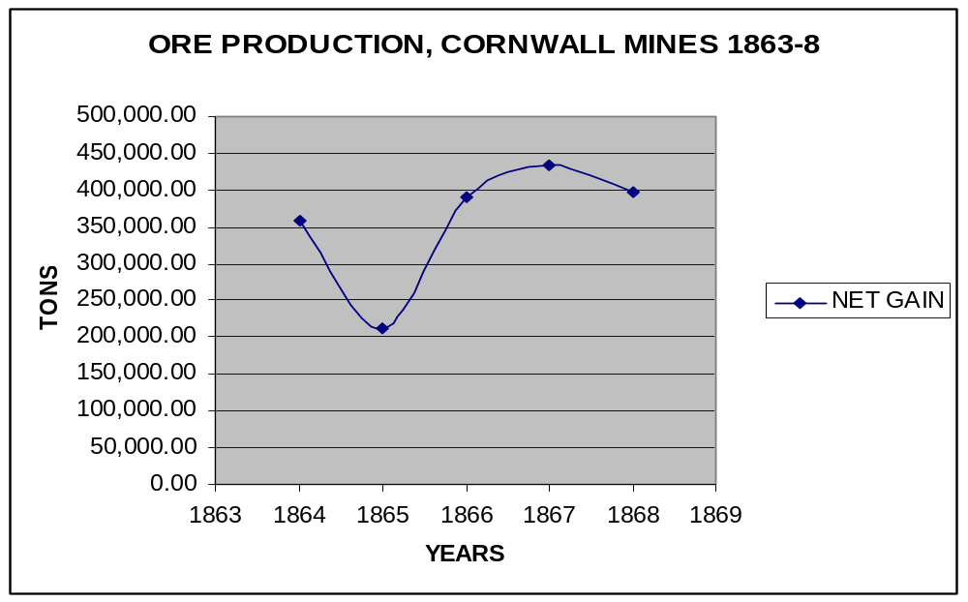
Researchers should also be aware that some photographs of the Robesonia furnace exist in the Albertype Company Collection taken by a Lebanon County photographer.

III. Guide to Individual Interpretation Plan Questions:
This section will attempt to connect portions of HSP’s collections—ledger books, correspondence, secondary sources—to individual questions in the Cornwall Iron Furnace Interpretation Plan. Where possible, charts, tables and graphs will be utilized to demonstrate how data can be aggregated, analyzed and represented.
Cornwall Furnace’s physical infrastructure:

Question 6: What is the complete set of area buildings (those under state and private ownership) that were originally part of the Cornwall Furnace plantation? What buildings in the area were influenced in their design by the design of buildings at Cornwall?

The following collections possess materials relative to the growth and evolution of Cornwall’s built environment. As indicated in the collections overview, the Minutes of the Cornwall Ore Banks Company provides considerable insight into the date of construction of various collections of workers’ housing, or when modifications to the plant were made. In Box 2, Folder 8 of the Grubb Collection (1967) a letter exists indicating that “Bill Sullivan will cast your bellow pipes of you send him your pattern,” and in folder 4 of the same box, an undated invoice probably from the 1780s mentions the cost of “making a waterwheel for Peter Grubb 14 feet high at 13 cir”. Often times, the general superintendent will remark on the type and characteristics of the structure built—especially with regard to materials. An interesting methodological choice would be to assess the various commodity and cash books for sales of building materials at crucial times. Determining who is purchasing these materials can also provide insight into the expansion of the physical infrastructure at the site. For example, throughout the summer and fall of 1874, several charges were made for building material: brick, lathe, plaster, pine boards, stone, and roofing lathe. All of this may be incidental to the construction of the Coleman’s manor house designed by the Philadelphia firm of the Hewitt Brothers. That much of the building materials are charged to Mrs. Coleman gives credence to this assumption. And the detailed recordation of the number of bricks produced by Cornwall’s kiln also includes mention of the bricks’ destinations. Thus for September 4-17, 1877 some 56,000 bricks were removed, most of which were destined for “the new school house at Bird Coleman Furnace.” Mrs. Coleman again requested over 8400 bricks for a job a few days later. These brick tallies are yet another means of understanding the expansion of Cornwall’s built environment.
Question 8: Period maps of the Cornwall area should be identified, located, and copied for the site’s archives.

One map was identified during the course of the survey in the Cadwalader Collection, MG 1454 in Series 6: Judge John Cadwalader Collection, Folder 4. It is a portion of S. Clarke’s large survey of 1787 on rag paper describing the entire 750 acre plot of grassy, middle and large iron hills. On this hand drawn copy it indicates that that Peter Grubb owns a large parcel marked “No. 1” and Samuel Grubb owns a parcel marked “No. 2”. This map was probably made for illustration of where illegal ore extraction was supposed to have taken place.
Working at Cornwall Furnace:

Question 14: How were ironworkers compensated? How much pay did they receive and in what form of currency? Were expenses like rental of company housing and purchases from a company store taken out of their paychecks as was the case with many coal mining companies? Were there additional side benefits, like free coal or wood for fuel for heating and cooking at home? Or did workers have to pay for those commodities?

Question 46: Does Cornwall Furnace’s history reflect the tension between the industrializing nation and the agrarian ideal? Or did the iron business enjoy a mutually advantageous, symbiotic relationship with agriculturalist neighbors?

Much of the data contained with the Cornwall Furnace section of the HSP’s Forges and Furnaces Collection (212) details the sale of agricultural products through the company store at Cornwall. As Frederic Shriver Klein notes in his treatment of Robert Coleman, the ironmaster learned as a young apprentice that a furnace could operate with a scarcity of working capital if it was not tied up in worker pay. Thus, credit at the company store sufficed as compensation for most workers. A close analysis of product flows out of the store can yield insights into the relationship of wages to expenditures and can assist researchers a better definition of real incomes at the furnace during the early part of the nineteenth century. Additionally, determining whether price and wage fluctuations mirrored those occurring in agricultural sectors may affect how scholars view the speed with which Cornwall workers adopted an industrial consciousness. Invariably this question is linked to one of the greatest questions framing the discussion of early industrialization: whether standards of living improved during this period when some segments of life at Cornwall were assuming a typically industrial character. In order to address this question as to whether Cornwall followed or diverged from the normal pattern of industrialization, researchers should look into the difference in the rates of upward mobility in “rural-protoindustrial” settings versus those in high density urban settings.
Considerable scholarship exists on both price and wage fluctuations in agricultural and urban settings against which aggregated data from grain books, mill books, provision books, ledgers and journals can be compared. In urban settings like Philadelphia during the early National period, real wages were said to rise some 63 percent between 1790 and 1830. This, however, does not mean that the rate of real wages exceeded the cost of living; rather, despite substantial wage increases after 1790 and between 1800-30, the cost of living began to outstrip wage rates. If we have determined that expenditures for food—particularly meat and wheat—comprised nearly 50 percent of an average Cornwall furnace worker’s monthly expenditures, then we should pay close attention the price of three bushels of wheat over time. Wages at Cornwall in the early 19th century largely followed the pattern of the regional agricultural sector, with agricultural workers in Philadelphia accruing a monthly total of somewhere between $9.022 in 1801-1810 to $9.312 in 1821-1830. Using Donald Adams’ research into wage rates and grain prices in rural Maryland, the data from two chronological points is worth comparing to Cornwall. Adams found in 1828 that the index of meat and grain was 161.0 and the wage rate was 188.0 leading to a food-to-wage index differential of roughly .85. By 1850 this food-to-wage index differential had reached 1.38, suggesting that food prices were far outpacing agricultural wages. This impact of this differential is all the more severe considering the rising cost of wheat at Cornwall in the early 1850s, with the price skyrocketing to 6 dollars for three bushels in 1854. (See below).

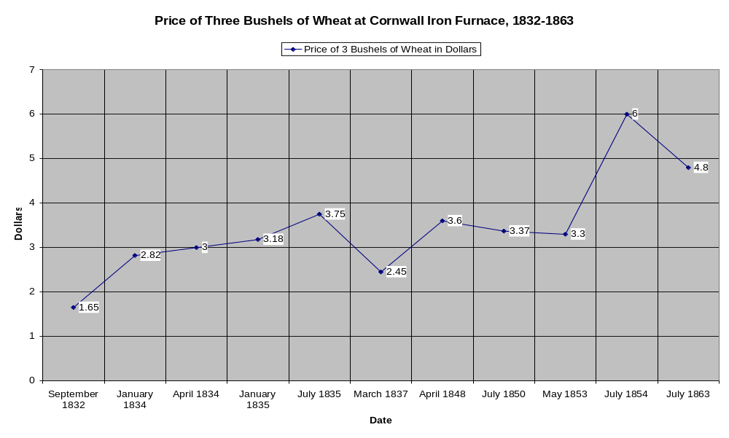
Further analysis of this type is necessary to determine whether conditions at Cornwall correspond to wage/price fluctuations in other regional sectors. This simple sampling of wheat prices shows two commonalities with Adams’ conclusions: first, the almost 35 percent decline in wheat prices during the Panic of 1837 compares favorably with Adams’ 28 percent drop and the rising prices in the 1850s is consistent with “the pattern of rising prices which preceded the panic of 1857.” Secondly, conditions at Cornwall appear to bear out Adams’ suggestion that everything from oats to rye to wheat doubled in price between 1750 and 1850. Further analysis must be completed to determine whether the experience of industrializing Cornwall was similar to the experience of Maryland farm workers and their counterparts elsewhere, who “experienced only meager gains between 1750 and 1850”. Utilizing the materials at the Historical Society of Pennsylvania, researchers are well equipped to answer these broad questions that frame the study of workers’ conditions over time. Researchers should pay close attention to ledgers spanning the years 1764-1871; provision books spanning 1820-1881; the grain order books spanning 1826-1872; in order to contribute to the debate over the speed of, and reception to, industrialization at a rural furnace.
Foodstuffs and other perishables were eminently popular, items such as beef, bacon, flour, ham, and potatoes were consistently purchased every pay period. Even by the 1850s the company store inventory contained nails, shaving boxes, shoe soles, and specialized good such as dog sled(ge) handles. As alluded to in prior reports, the above ledger and cash books also show Cornwall connected to a nascent consumer good distribution network. Beginning in the mid-1860s, purchases began to include coal in counterweight measures, tallow in pounds, greater quantities of salt and sausage – indicating that more specialized food products were making their way to the furnace. Whether products like sausages were made on site or elsewhere is unknown. Researchers should attempt to trace the possible connection between new foodstuffs and R.H. Coleman’s growing interest in “scientific farming” in the 1870s-1880s.
While the prices of consumables, when interpreted in conjunction with worker pay can yield insights into real wages—close attention to commodity purchases can give clues as to preferential treatment at the store, ongoing construction projects occurring around the complex, costs of education for Cornwall workers, and the comings and goings of the Coleman elite. In fact, the Colemans are billed for messages to family members on board transatlantic ocean liners docked in Philadelphia for hauling building materials to their jobsite, and for the building materials itself. Though the Colemans were the chief proprietary family enjoying a kind of feudal lordship over the furnace and mine, they, too, accrued debts at the company store.
Question 22: How were iron masters’ families interrelated? How did intermarriage affect the relationships between different iron plantations?

Question 29: What was the role of politics at Cornwall Furnace? How did the Giles, Grubb, and Coleman families’ political beliefs shape the operation of the furnace?

While the collections at HSP do not shed light on the political tendencies of workers, Frederic Shriver Klein’s “Robert Coleman: Millionaire Ironmaster” which appeared in the Winter 1960 edition of the Journal of Lancaster County Historical Society excels in its depiction of industrial intermarriage in the late eighteenth and early nineteenth centuries. Klein highlights the importance of intermarriage as a protection from personal failure in a time of limited credit. Intermarriage, Klein writes, “produced a sort of feudal empire, which combined capital, preserved property holdings in the event of the death of a partner or associate and enabled vast estates to remain in the families and to grow as the families grew.”
Klein’s essay on Coleman also attributes much of the ironmaster’s success to his Federalist tendencies. It appears that his personal and political connection to John Dickinson allowed him to buy out the Pennsylvania farmer’s share of the Elizabeth Furnace, which Klein refers to as Mary Norris’s dowry when she married Dickinson in 1770. By 1794 he was able to purchase the final third from Daniel Benezet and own the furnace outright. Coleman’s devotion to the Federalist Party seems to have played into his appointment to the bench in 1791. Klein makes a strong case that by cultivating relationships with wealthy Federalist families and making assiduous investments at timely junctures Coleman was able to become the Commonwealth’s first millionaire.
Question 24: How did free black workers fare at Cornwall Furnace?
The collections at HSP do not add slight definition to the story of slave or free black labor at the Furnace. As alluded to prior, slaves were physically bound to the furnace but could purchase goods at the store and were often times trained in skilled jobs. Occasional mention of what can be presumed to be slaves or free blacks can be found in the time books and in the Miscellaneous Index Book dating from the 1770s or the early nineteenth century. From the Sundry Daybook for 1771-1773, a note indicates that several slaves were charged for “shoemaking” and “leather britches” and “knives”. In this same book of a list of slaves, David Jones was listed as an “apprentice.” Almost always slaves are grouped together in the account books and their names are preceded by “Negro” as in “Negro Joc.”, “Negro Greg”, “Negro Betty Sharp”, “Negro Isaac”, “Negro Fanny,” and “Negro Acco”. Sometimes black workers are listed with their job titles, though infrequently. As mentioned prior, some material in the Grubb Collection MG 1967A-B suggests that legal instruments like indentures cut both ways for slaves and free blacks. While restricting their physical mobility these indentures required masters to provide specialized training in furnace trades. A mention in the Sundry Daybooks for 1771-1773 mentions that Ball (Batt) Hailey owed Negro Scipio “for putting in Night Stock on Sunday”, night stock being the night stock of charcoal. This in turn, indicates that Scipio was entrusted with an essential job of maintaining an adequate stock of charcoal.

Cornwall Iron Furnace as a Business:

For the discerning researcher interested in Cornwall as a business, collections at HSP provide excellent insight into the cost of various processes like coaling, productivity rates, and the destination of pig iron throughout the eighteenth and nineteenth centuries. The ledger books Coal Log 1833-1848 and Coal Book, 1851-60 detail costs and charges associated with the haulage of charcoal by coalers. Of the coalers listed, most are Germanic or Pennsylvania Dutch in their ethnicities, as is expected of the Cornwall complex in the middle 19th century. Represented in this data are two features: 1.) individual production totals which give indications of the fluctuating difficulty or quality of work over a yearly period and 2.) charges for rail transportation of charcoal. Though charcoal production was relatively inexpensive in labor and materials, these transportation costs could indicate how deforestation forced the importation of coal from greater distances. Additionally, the importation of charcoal from farther distances may have eliminated any cost savings associated with the fuel’s production.
Most workers, it was found, hauled about 3 tons of coal a day. During the 1830s, the heaver teams worked for a higher skilled coaler and were organized into four man groups with each member. Coalers tended to use the same labor teams or keep the core of his team with occasional substitutes. The Coal Log book for 1833 begins in April and indicates that a load consists of 4.5 cords of wood. This ledger indicates deductions but it does not mention the rationale for these deductions.
By the 1850s, workers were producing roughly 2-3 tons daily at the beginning of the season with this number nearly tripling by the Fall of the year. The ledger records for 1851, “Receipt of Coal Hauled by George Bowman” show an amazingly consistent work output:
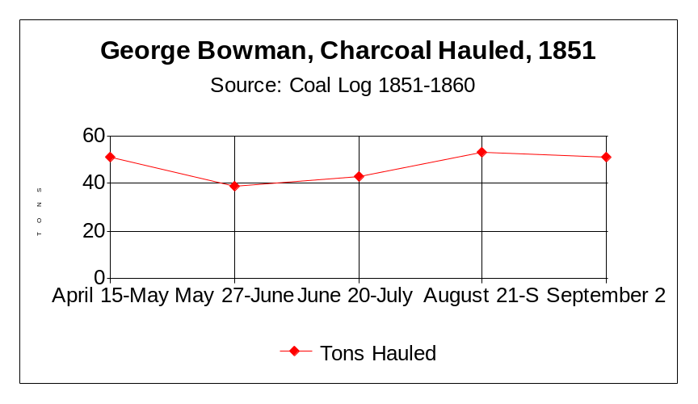
Despite these astounding output rates, by the end of the 1850s managers had begun employing the railroad to haul charcoal—a curious application to new technology to the movement of an essentially ancient fuel. By 1859, an average railroad load of charcoal was 25-32 tons, a ten-fold increase over the average daily tonnage of a human hauler just a decade before. Thanks to the application of the railroad, the Cornwall Coal Log for 1859 indicated the following totals for “R. Hecksher and Company by RR”:
Month | Amt. hauled in tons
August | 822
September | 745
October | 1245
November | 824

In light of these numbers, it remains for researchers to determine whether shipping charges were low enough to justify the continued importation of the fuel versus the adoption of anthracite or bituminous fuel. The possibility that Cornwall imported charcoal may shed light on question 57 of the Interpretation Plan. Researchers should also avail themselves of Coal and Cordwood Books for the years 1798-1814 to see how labor gangs were organized and managed and how productivity remained somewhat stable over these years before rail transportation, suggesting little change in the techniques of coalers and their haulers.
Question 31: Was there industrial sabotage or cutthroat competition?
Over the course of this survey, only one documented instance of labor disputation was encountered through Miller’s The Rise of an Iron Community. Miller refers to a strike at the Ore Banks in April 1864 when the miners struck for a raise to $35.10 versus $33.60 a month. Most likely this agitation was a response to increased pressure on miners to increase their output. Miller reports that the dispute was significant enough to merit the involvement of Sherriff Stouch of Lebanon and a posse of 50 men. While their presence forestalled any riot, six men were charged with disturbing the peace and Richard Mullin, Anthony Worley, and Jonathan Witman were found guilty of conspiracy to commit an illegal act.
Question 35: What were Cornwall Furnace’s markets? How did they change over time?

Consistently throughout its time at as a furnace, Cornwall served a mostly regional and statewide set of markets. In the latter half of the eighteenth century, Cornwall produced finished products such as salt pans, stoves, and other iron implements in addition to armaments during the Revolution. Most of its output, however, was in unfinished pig iron. Researchers wishing to document the destination of these pig iron shipments should review the Blast and Pig Iron Books spanning the years 1776-1792. A transcription of the weight and destination of pig iron shipments during 1776-1777 is attached to this document as an Appendix. George Ege’s Charming Forge, Conrad Engel’s Hopewell Forge, James Old’s , Charles Lukens’ and William Alexander’s operations, Mt. Hope Forge, and Christian Lower and Company’s forge were routine customers during this period. The run of blast and pig iron books are strongest throughout the nineteenth century, from roughly 1798 to 1883.
Technology, mining, and iron products:
Question 51: What mining techniques were used? For example, did they use explosives like dynamite to expose the ore?

Good material exists to flesh out the story of mining at the Ore Banks in the nineteenth century. The Minutes of the Cornwall Ore Banks Company, in addition to Time and Payroll Books, Ore Bank Books, and secondary sources provide insight into the adoption of new techniques and technologies to the extraction process, job classifications and pay rates, destinations and quantities of ore, the gradual relinquishment of the company to large scale integrated industrial corporations, and labor disputes, social conditions, and the evolution of the mining built environment.
While the demand for ore throughout the nineteenth century remained fairly stable, by mid-century Cornwall Ore Banks Company was ramping up its production capacities. By replacing time honored though inefficient quarrying techniques with the newer “bench system” of terracing mining, one miner could extract from five to ten tons of ore a day. Mechanical tools, dynamite, and narrow gauge railroads increased productivity markedly. The Time and Payroll Book spanning 1902-1911 is crucial to understanding how occupational categories and skill levels correlated to pay rates in the early 20th century as the Ore Banks were shedding some of the former labor classifications and becoming increasingly mechanized. In March of 1902, the categories at the ore mine were: Miller, Engineer, Driver of Mule Team, Helper, Watchman Women, for the first time, engaged in cleaning and building service occupations are formally noted as receiving pay. In the early part of the century, Susan Ruto was paid $2.00 monthly to clean the company’s office.
Through this book, one begins to understand that real earnings were always
circumscribed by rent debts and debts to the company store. For example, Oscar
Galebach, a mule team driver, worked 26 days out of a month and made $32.00 gross.
For milling of some grain he was docked $2.10, $2.43 for coal and $3.00 for rent. His
total deductions amounted to $7.53, meaning that Galebach made $24.47. In other situations workers only broke even on account of their debts. Additional research is
required to determine whether unskilled workers worked their way into skilled job categories and for workers living in company housing who shopped at the company store,
what proportion of income was retained over time.
Question 56: What other iron/steel plants got ore from Cornwall Banks? Where was it shipped/sent besides Cornwall? Robesonia? Charming Forge? Newmarket? Monroe?

Documents like the Sales Book spanning 1882-1884 testify that while output at the mine was increasing, Cornwall was mainly distributing to regional specialty mills in Pennsylvania, New Jersey and Delaware, with the bulk of their customers in Pennsylvania. The following chart indicates the type and character of Cornwall’s clients. Interestingly enough, Cornwall seems to have thrived on the basis of two steelmaking clients, the Scranton Steel Company (an offshoot of the Lackawanna Coal and Iron Company) and the R.D. Wood Company in Florence, NJ. Both were making specialized products, Scranton was making rail and Wood, water pipes and industrial machinery. Ore sales to these two customers comprise 75.2% of the mine’s total output for May 1884 based on analysis of the sales book for this month. While Cornwall thrived on select firms making big ore purchases, it also serviced 8 consumers whose sales comprised less than 10 percent of total ore sales.
Some of these firms, too, were creating specialty goods. Bethlehem Steel, for example, in the 1880s was beginning to develop its specialty Harveyized steel plate for naval applications. Due to these demands, Bethlehem consumed only 5.3 percent of the mine’s total output that month but the ore was almost always higher quality, more expensive “No. 2” grade.
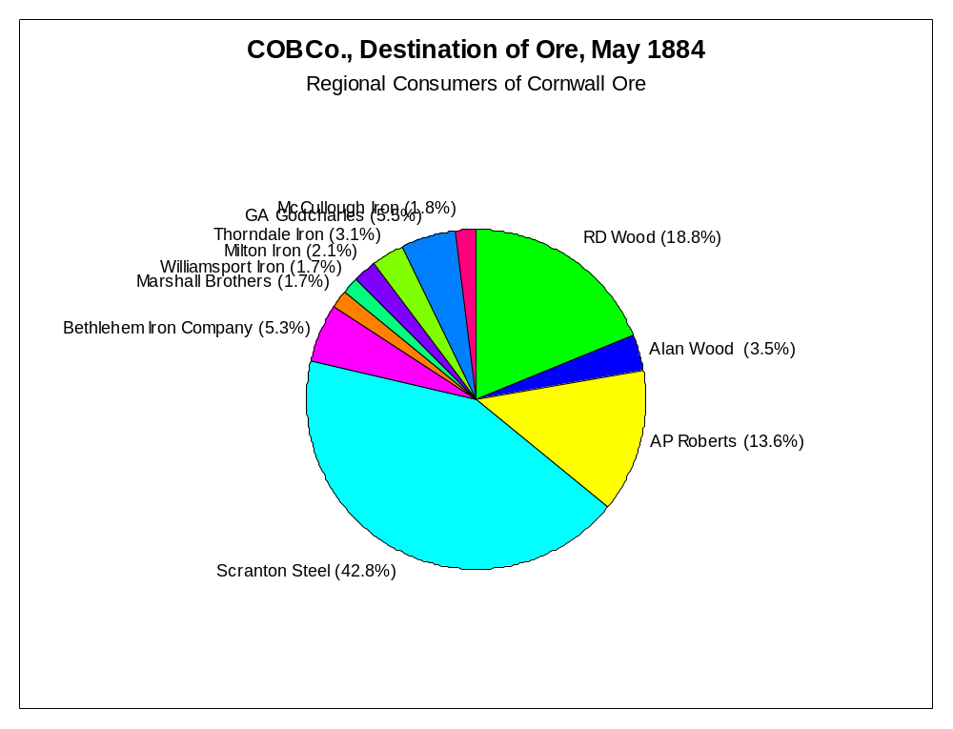
Interesting patterns also emerge when you project this data spatially. While Scranton Steel is well represented on the map, Cornwall’s connectivity to the Philadelphia region, perhaps via the Reading Railroad, is also telling in the concentration of medium sized customers for May, 1884. Besides Philadelphia and Scranton, a small concentration of ore customers exist around Williamsport. Where possible, researchers should take pains to analyze disaggregated data spatially. (See below.)
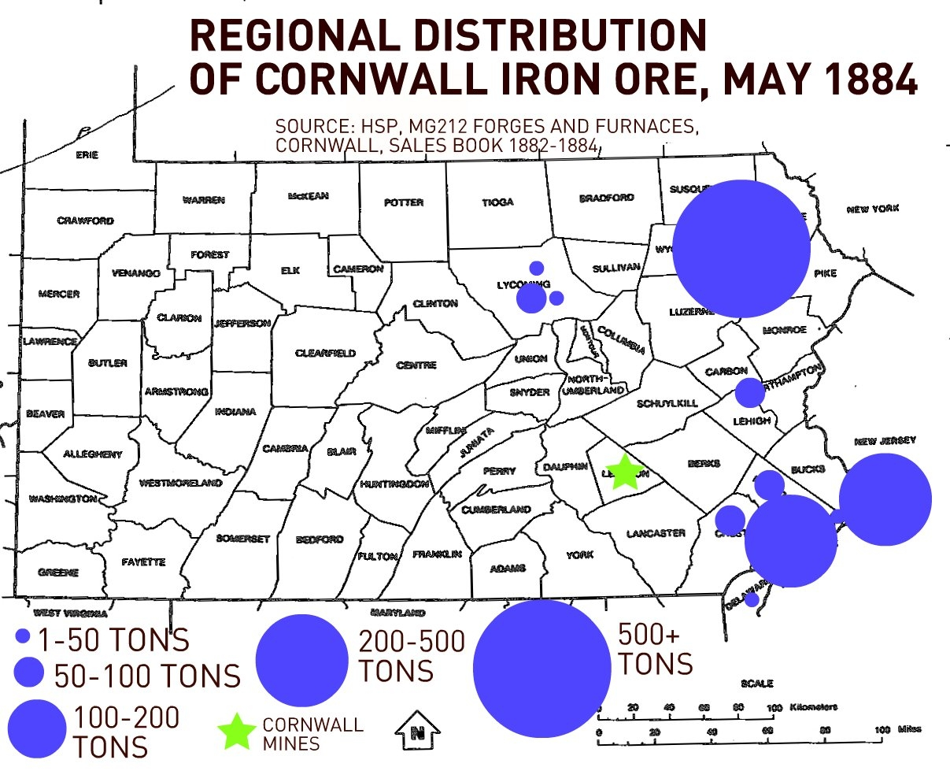

© CHRISTOPHER R. DOUGHERTY 2009

For an overview of materials relating to the Cornwall Furnace and Ore Banks at the Pennsylvania State Archives, please see: http://www.cornwallironfurnace.org/CORNWALL_FINA.pdf
Cadwalader Papers 1454, Series 6, Box 332, Folder 4. Correspondence.
Cadwalader’s papers are filled with correspondence with noted geologists, newspaper accounts of mining operations and techniques, and drawings of ore seams.
Frederick K. Miller, The Rise of an Iron Community, 72.
In 1869, both parties appealed and another judge upheld Pearson’s reading of the case.
Miller, The Rise of an Iron Community, Vol. 1, 74.
Cf. Miller, vol. 1, 74.
Coleman v Grubb, (1854)
Cadwalader Papers 1454, Series 6, Box 332, Folder 4. The survey in question was Thomas Clarke’s survey of 1787 which defined rights to the Big Hill, Grassy Hill, and Middle Hill. There are several copies of the survey, some traced by Cadwalader, that appear in these files.
Cadwalader Papers 1454, Series 6, Box 332, Folder 4. Italics added.
Miller, The Rise of An Iron Community, 69.
James T. Lemon, “Urbanization and the Development of Eighteenth-Century Southeastern Pennsylvania and Adjacent Delaware,” The William and Mary Quarterly, 3rd Ser., Vol. 24, No. 4 (Oct., 1967), pp. 501-542.
Francis Fukuyama’s definition of social capital as an “instantiated informal norm that promotes cooperation” is operative here. For social capital to manifest itself, these norms must “lead to cooperation in groups and therefore are related to traditional virtues like honesty, the keeping of commitments, reliable performance of duties, reciprocity, and the like.” Francis Fukuyama, “Social Capital and Civil Society,” Speech delivered to the IMF Conference on Second Generation Reforms, George Mason University, 1 October 1999.
Grubb Collection 1967, Box 2, Folder 8.
See Kenneth Ressler, “Cornwall’s Iron Economy,” Lancaster County Historical Society, Vol. 67, No. 1, 1967., 59; See also Paul Paskoff, Industrial Evolution: Organization, Structure and Growth of the Pennsylvania Iron Industry, 1750-1860 (Baltimore: The Johns Hopkins University Press, 1983)
Grubb Collection 1967, Box 2, Folder 8.
Ibid.
Another supplicant, Adam Weaver, wrote pleadingly to Grubb at Lancaster in 1785 that unless someone pays one hundred and seventy pounds Weaver would “gid execution on me.” It is unclear whether Grubb assisted.
Grubb Collection 1967, Box 2, Folder 11. Most documents relate to Mt. Hope Furnace. Colliers appear to have received the most contracts due, in part, to the significance of their work.
It is unclear why Peter Grubb, Jr. sold his share of Cornwall.
Grubb Collection 1967, Box 2, Folder 7.
Grubb Collection, Box 2, Letter of 25 October 1785, Robert Coleman to Peter Grubb: “I otherwise expected to have your final answer respecting the forge before this time
Ibid.
For additional detail please see finding aid: http://www.hsp.org/files/findingaid212forgesandfurnaces.pdf
Cornwall (charcoal) is idiosyncratic in its “industrial” development as some highly characteristic features of industrialization are absent while others are present. While the firm did not adoption many new technologies at the charcoal site, it did experience new market relationships. While rural until the late 19th century there were signs of class and skill stratification by this time. These conflicting characteristics make Cornwall’s industrial development atypical.
Frederick K. Miller, The Rise of An Iron Community: An Economic History of Lebanon County, Pa. from 1740 to 1865, Vol. 3 (Lebanon: Lebanon County Historical Society, 1948), 168.
This remains for researchers to determine. Paul Paskoff has explored the difference between multiple and single-proprietor firms in his study of the modernization of the Pennsylvania iron industry but has not addressed this question of personal liability and exposure in the 18th century. Klein comes close to claiming this when he argues that combining fortunes through intermarriage “produced a sort of feudal empire, which combined capital, preserved property holdings, in the event of the death of a partner and enabled vast estates to remain in the family and to grow as the families grew.”
Jack Bitner, Mt. Gretna, A Coleman Legacy: A History of Mt. Gretna and the Coleman Dynasty (Lebanon, PA: Lebanon County Historical Society, 1990), 19.
http://www.lehigh.edu/library/speccoll/fritz.html
In the possession of the State Archives, Harrisburg. See earlier Research Action Plan.
HSP, Lebanon County, PA Clippings, Scrapbook VoL. #.599
VoL*. 37 v. 1, Pennsylvania Court of Common Pleas, C.B. Grubb vs A.B. Grubb, June 25, 1875., 1-16.
Minutes of the Cornwall Ore Bank Company, 118.
Often times, shareholders would read complaints associated with this dispute into the minutes of the Cornwall Ore Banks Company.
Minutes of the Cornwall Ore Bank Company, 20 March 1867
Please see online viewing aide for additional information about the Albertype Company: http://www.hsp.org/files/findingaidv18albertype.pdf. Please also refer to Collection V-18A for additional shots of
Whether or not they paid these debts or were given preferential prices remains to be explored. See Commodities and Cash Books: Store Ledger 1853-56 and Cash Book 1874-76 for additional information.
Cornwall Furnace Memorandum Book 1877, Section 5-6.
Cornwall (charcoal) is idiosyncratic in its “industrial” development as some highly characteristic features of industrialization are absent while others are present. While the firm did not adoption many new technologies at the charcoal site, it did experience new market relationships. While rural until the late 19th century there were signs of class and skill stratification by this time. These conflicting characteristics make Cornwall’s industrial development atypical.
See the work of Jurgen Kocka, in “The Study of Social Mobility and the Formation of the Working Class in the 19th Century,” Le Mouvement Social, no. 111, Geeorges Haupt parmi nous (April.-Jun. 1980), 101-102. “Apparently,” Kocka writes, “industrialization had a very different effect on social mobility depending on whether a place was urbanized before, or not.” Official NPS histories of Hopewell, for example, characterize wages and conditions as better than those in urban industrial contexts.
Donald R. Adams, Jr. “Wage Rates in the Early National Period: Philadelphia, 1785-1830, The Journal of Economic History, Vol. 28. No. 3 (September 1968), 414.
Adams, Wage Rates, 415.
As stated in the prior interim report: “Investigation of HSP’s collection of sundry daybooks from the early 1770s has yielded important insight into the consumption patterns of average workers and slaves. Following one worker, Barney Donnelly, through a month of purchases shows that his outlays occur in four major areas: tobacco, foodstuffs, alcohol, and clothing. By far the largest proportion of his total purchases during 29 October – 30 November, nearly 50% were for food, mainly beef averaging between 9 and 14.5 lbs.”
Donald R. Adams, “Prices and Wages in Maryland, 1750-1850,” The Journal of Economic History, Vol. 46 No. 3 (September 1986),
See Adams, Table 2, “Index of Wage Rates and Meat and Grain Prices, 1752-1850,” in 1850 Meat and Grain Index, 207.1 while wages had fallen to 150.4
Data compiled from Forges and Furnaces, 212, Cornwall Provision Books 1832-1844; 1848-72. See also Cornwall Store Ledger 1853-1856 for wages and price tabulations.
Adams, Antebellum Wages and Prices, 627.
Ibid., 636.
According to the Cornwall Memorandum Book for 1877, clerks began to keep detailed data on the types of cows or hogs—heiffer, Dutch, “Mansion Bulls”, their weight and meat production, and number killed. In addition it is clear that Cornwall utilized their “Western’ cows for beef.
Whether or not they paid these debts or were given preferential prices remains to be explored. See also Cash Book, W.G. Freeman, 1874-76 for commodity prices and changing consumer tastes.
Klein, “Robert Coleman: Millionaire Ironmaster,” 21.
It is believed that the later coal book ledger relates to the charcoal furnace.
For example: John Dohner, Jacob Witmer, Oliver Bormann, Samuel Erb, Christian Dohner, Moses Baker, Jacob Garmin, Jacob Baker, Levi A. Yocum. In reference to Interpretation Plan Question 38.
Meaning, did the relative cheapness of making the fuel offset transportation costs and at what point did transportation costs tip the balance.
Miller, The Rise of an Iron Community, 75.

